Assignment

Day-10

1. What is clearfix class in bootstrap? Why do we use it?

Clearfix property clear all the floated content of the element that it is applied to. It is also used to clear floated content within a container. Example 2: With clearfix property. Without using the clearfix class, the parent div may not wrap around the children button elements properly and can cause a broken layout.

To use the clearfix class, you add **.clearfix** to the parent element. This clears all the floated content of the element that it's applied to.

**The clearfix class is useful because it:**

* Removes the floating of an element in a container that is linked to its child element
* Prevents margin-collapsing of the first child element
* Helps make elements display best

Without the clearfix class, the wrapping div would not span around the buttons, which would cause a broken layout.

Ques2. How to hide the html tags using Bootstrap? Implement an example?

Ans: <body>

   <h1>Hiding an element using bootstrap</h1>

   <button class="invisible m-2 p-2 w-25 h-25">Press me</button>

   <h2>Hy I am up here</h2>

</body>

Output:

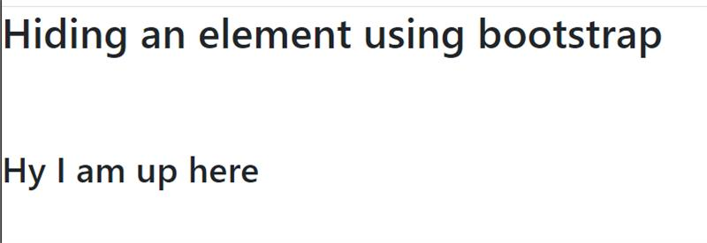

Ques5. What is Accordion in Bootstrap?  Study and Create an example with it?

Ans: The Bootstrap accordion is a component that organizes content within collapsible items. Accordion allows the display of only one collapsed item at a time.

Accordions can toggle through a number of text blocks with a single click, and that greatly enhances the UX of your project.

Ques6. What is spinner? How to create spinner using Boostrap?

Ans: Bootstrap “spinners” can be used to show the loading state in your projects. They’re built only with HTML and CSS, meaning you don’t need any JavaScript to create them. You will, however, need some custom JavaScript to toggle their visibility.

For accessibility purposes, each loader here includes role="status" and a nested <span class="sr-only">Loading...</span>.

<body>

   <div class="spinner-border m-5 text-primary" role="status">

       <span class="sr-only"></span>

     </div>

     <div class="spinner-grow m-5 text-danger"  role="status">

       <span class="sr-only"></span>

     </div>

</body>

Output:

